

VIRTUAL POS (FREEPOS)

Training Document





Directorate of Payment Systems
ADK - Product Development
GENERAL INFORMATION
What is Free Pos (Virtual Pos)?
- Free Pos (Virtual POS) is a form of POS device or system used for ordinary shopping, allowing you to shop through websites. Free Pos (Virtual POS) allows you to pay by credit card when shopping on the internet.
- With Free Pos (Virtual POS), an online payment system is established between the customer and the merchant or the seller and the supplier. The system may be summarized as the transfer of money, which is the price of the product or service purchased, by the customer, from the customer’s account in a bank or credit institution to the merchant’s bank account, by the customer entering his/her information in the merchant’s website.
Free Pos (Virtual Pos) Features of Use
- It enables payment with a card on the e-commerce system, in virtual stores and via the Internet.
- It finalizes the provision transaction of relevant banks in the central system with the card information and collection amount sent via the Internet, and forwards the provision result to the member merchant’s sales system.
- It transfers the feedback of transactions made in the member merchant’s system, according to the provision result, to the web environment. Thereby, the transaction is controlled transparently. All these transactions are completed in only a few seconds.
- At the end of this transaction, the total price of the shopping is deducted from the customer’s credit card and transferred to the member merchant’s account in the bank.
- To do so, the enterprise must sign agreements with member merchants.
- Our customers can apply for Virtual Pos at our branches. If a customer's application is approved following our assessment criteria, we then send them installation instructions via e-mail. Our customers can make the installation themselves on the website by following these instructions.
- Customers can set up their installment and point applications according to the conditions agreed on with the member merchant.
- Free POS (Virtual POS) supports installments; after installment definitions are created, installments can only be made for Sale Plus cards.
- There are two main user screens in Free Pos (Virtual POS). These are the “Virtual Pos” screen and BOA screen used by the member merchant over the internet.
Smart Menu
- Customers can use the smart menu to customize their use of Internet branch transactions.
- You can save a most frequently used transactions shortcut in the smart menu, or create a personal view.
- You can add a new transaction by clicking the “add” symbol and selecting the preferred banking transaction from the ‘all transactions’ list that appears on the screen.
- Customize the appearance of the transaction by holding the cursor (for 2 - 3 seconds) over the newly added transaction and using the “edit button” that appears in the upper right-hand corner.
- You can give this transaction a name and add your own image or select one from the many images available.
- To remove the shortcut, hold the cursor over the symbol (for 2 - 3 seconds) and click “remove” when it appears in the upper right-hand corner.
- Set or change the appearance of smart menu by clicking on the “list view” or “icon view” tabs that appear on the upper right-hand side.
- You can reach the shortcuts more quickly by saving them to the search bar on the upper right-hand side in the smart menu.

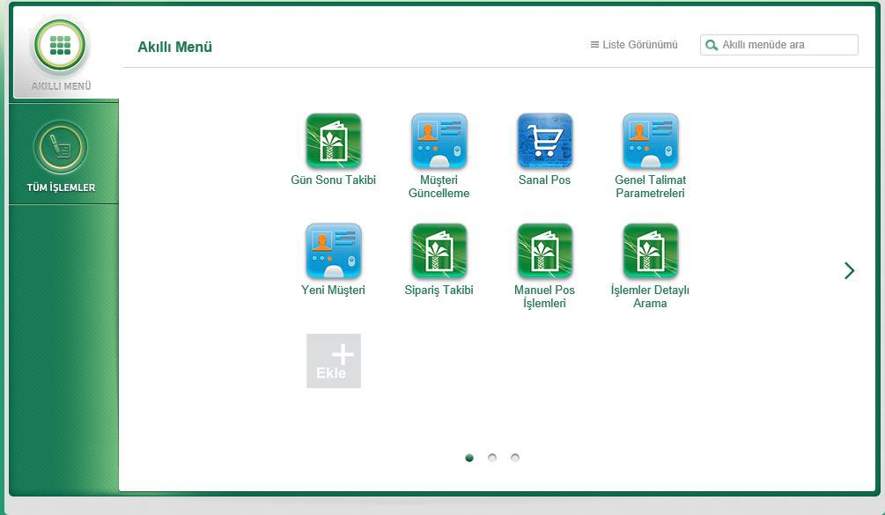

MEMBER MERCHANT SCREENS
- The Virtual Pos Internet branch login link is https://kurumsal.kuveytturk.com.tr.
- The Homepage consists of the Smart Menu and All Transactions areas.

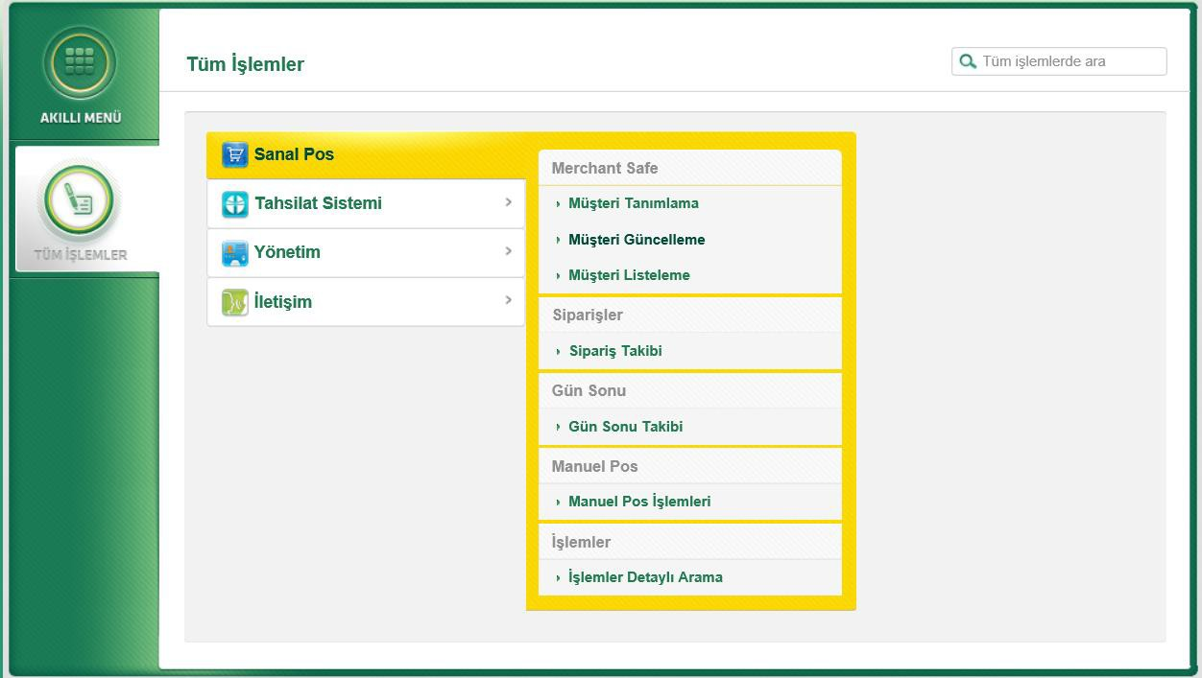

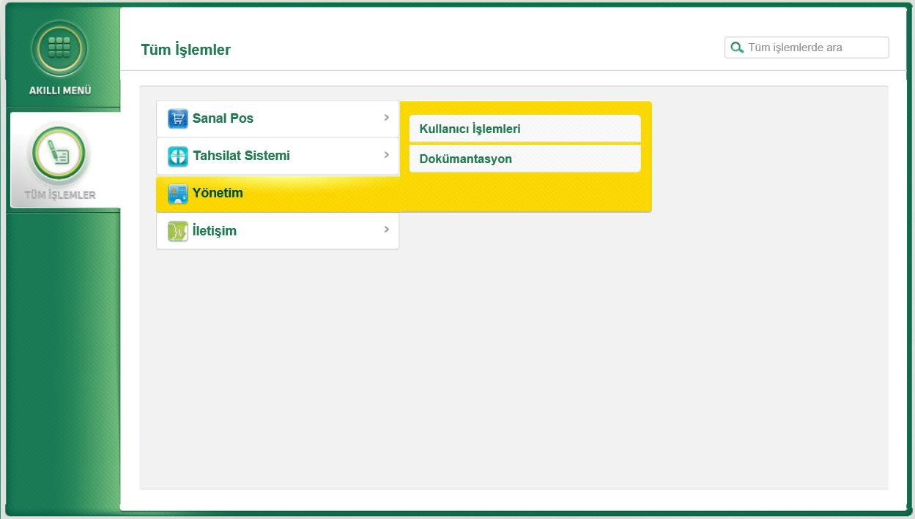

MANAGEMENT MENU

  - There are two titles in the management menu: User transactions and documentation..

On the user transactions screen; it is possible to Add user, Update User, Reset password and Remove Key.

  - Registration should be made in one of our branches in order to add users with Executive, Observer, Enterer role. Once a user is identified at a branch, it is possible to add that user and their authorisations by using the User Transactions screen.
  - There is no need to make an identification in branch screens in order to add a user with Api role. A user with Api role is the user that should be created to integrate the virtual pos to the site.
  - An Api user cannot log on to the https://kurumsal.kuveytturk.com.tr address.

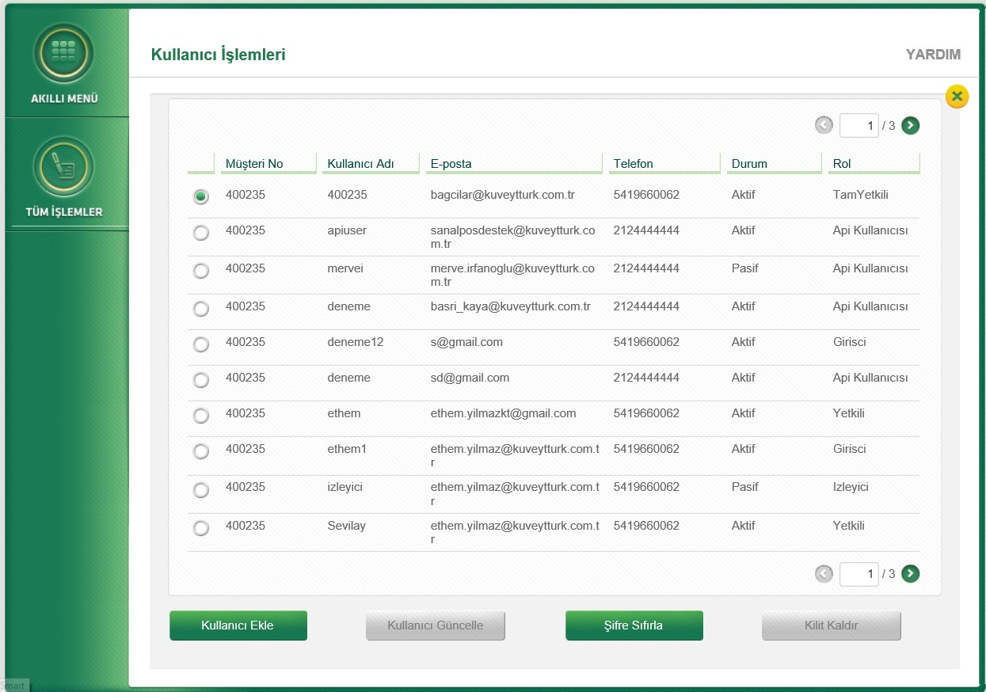

On documentation screens; there are codes and supporting documents to assist the member merchant in integrating virtual pos in the site.

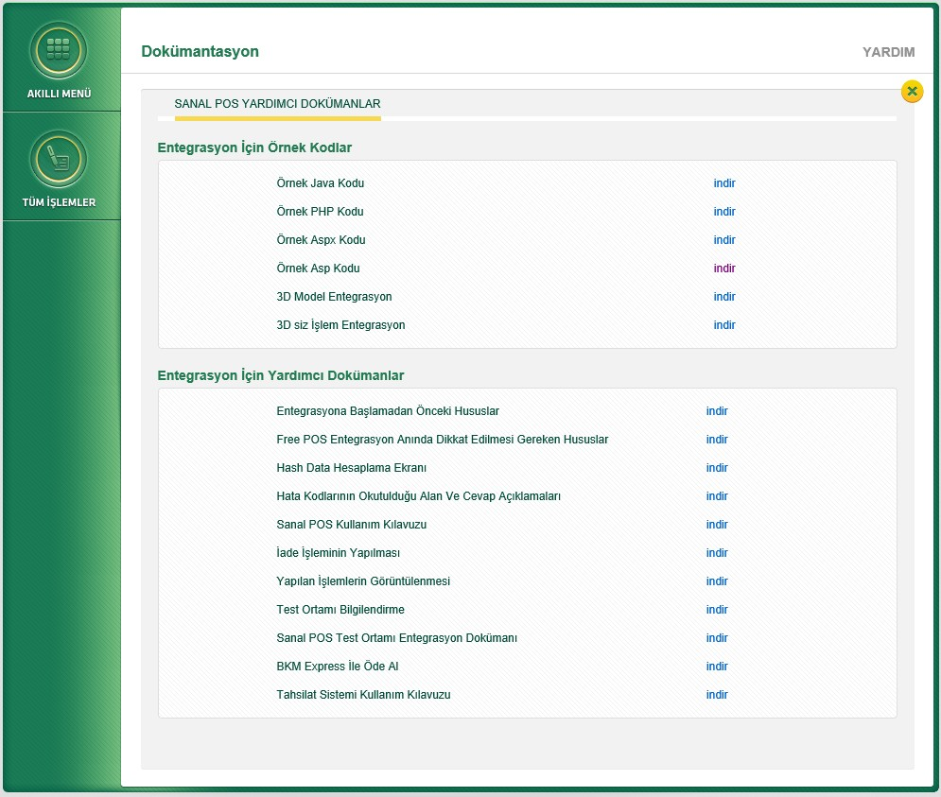

ORDER FOLLOW-UP

All orders made from virtual pos can be processed on this screen, and transactions made can be reported.

  - Transactions which received provision can be listed with time criteria as Today, and a chosen Date range, Yesterday, Last Week, Last Month, Last 3 Months, 6 Months, 1 Year.

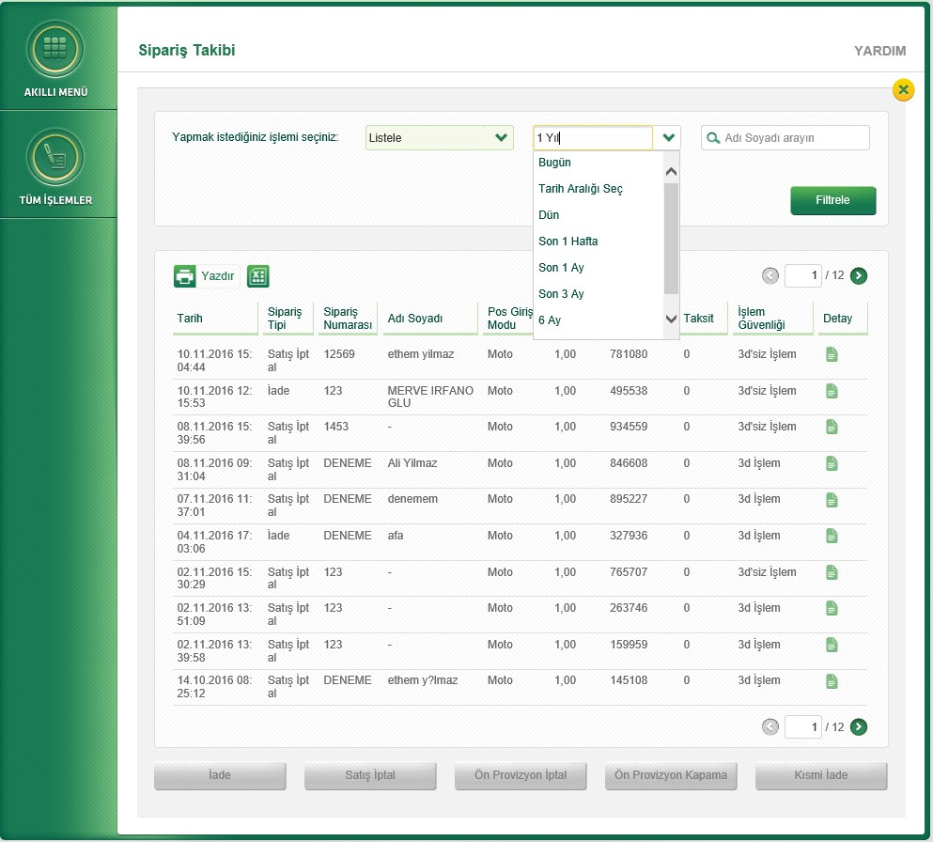

  - For returning successful orders, select the Return option from the “Choose transaction you want to make” field. Choose the transactions to be returned from among the listed orders and click on the active Return button.
  - If the transaction receives successful provision, the accounting operation is made and the return amount is sent to the card-issuing bank the next day.

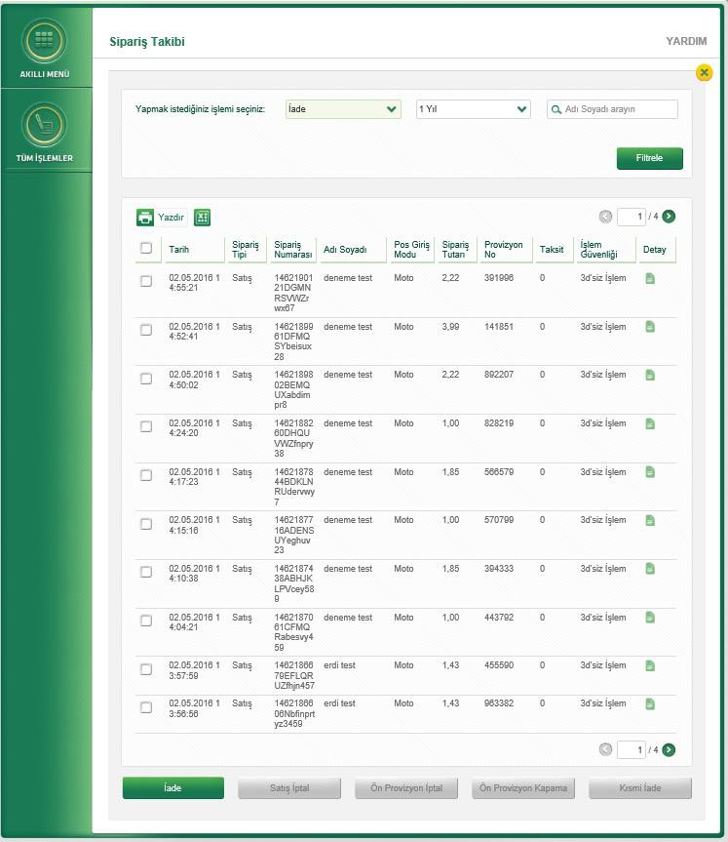

  - For canceling the sale of successful orders before the end of day, select the Cancel Sale option from the “Choose transaction you want to make” field. Select the transactions whose sales you want to cancel from among the listed orders and click on the active Sale button.
  - Transactions for which the sale is canceled successfully are not accounted and directly sent to the card’s bank.

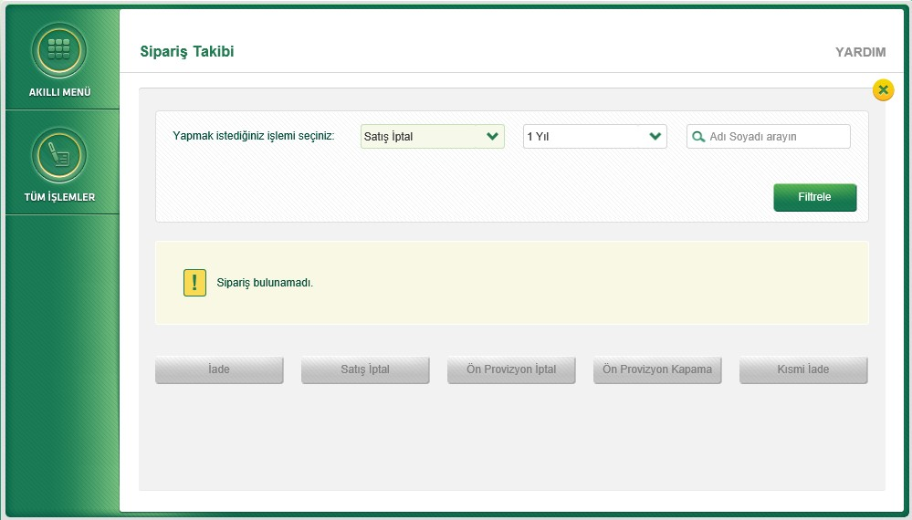

  - For partial return of successful orders, select the Partial Return option from the “Choose transaction you want to make” field. Select the transactions to be returned partially from among the listed orders, enter the amount of the return and click on the active Partial Return button.
  - If the transaction receives successful provision, the accounting operation is made and the partial return amount is sent to the card’s bank the next day.

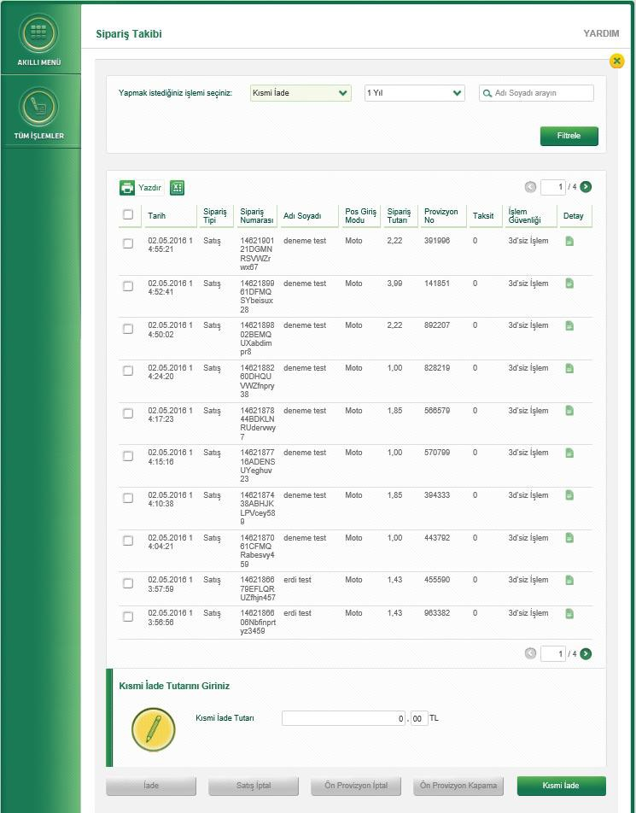

END OF DAY FOLLOW-UP

  - Open and closed end of day transactions are listed. Open end of day transactions are made.

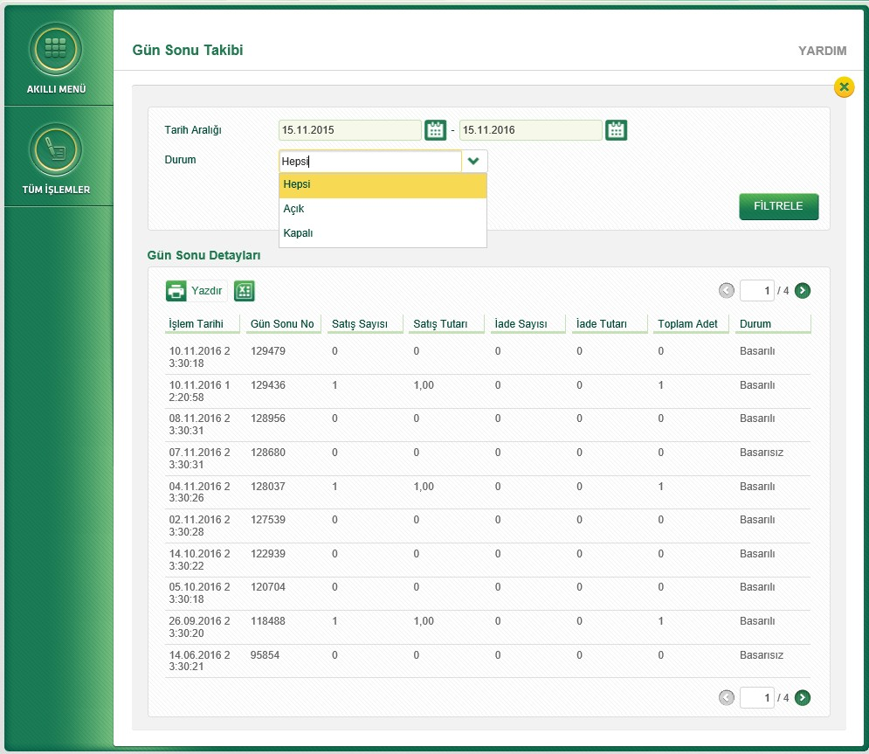

MANUAL POS TRANSACTIONS

  - Sales are made easily and rapidly without 3D by filling out the following fields completely on the manual pos transactions screen. Such information includes the delivery address for the products and the billing address.

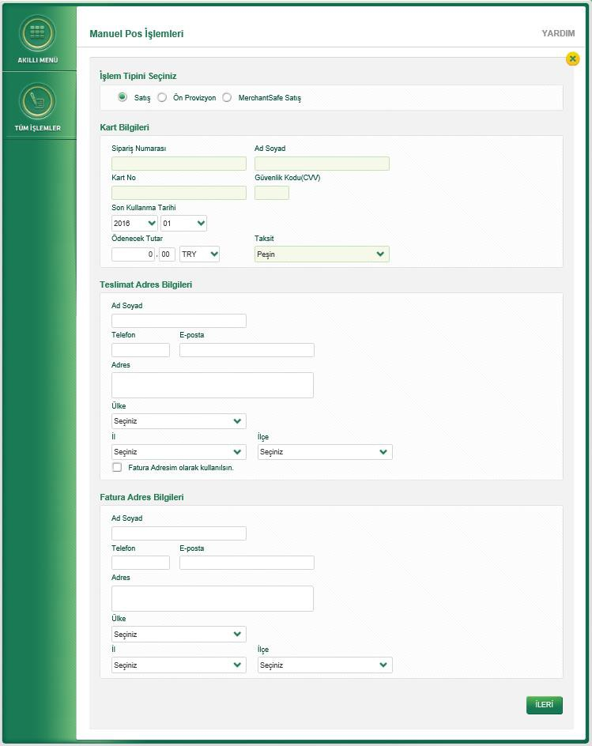

DETAILED TRANSACTION SEARCH
  - All successful and unsuccessful orders are reported on the screen.
  - Orders are listed with Time range, Card no, Transaction no, Provision no, Name and surname criteria.
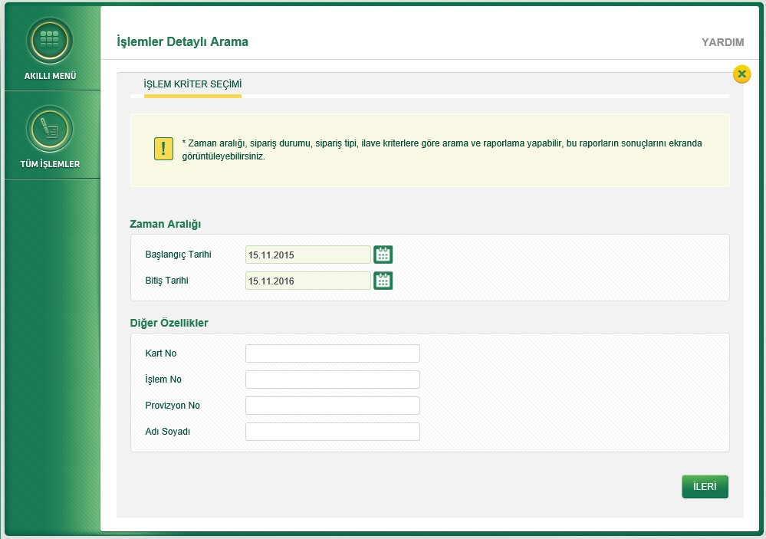

  - It is possible to transfer all successful and unsuccessful transactions to an Excel file and to print the screen.
